UNITED STATES DISABLED GOLF ASSOCIATION

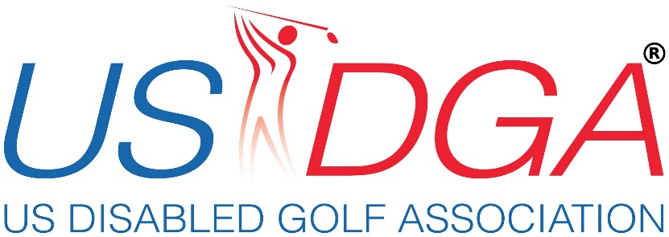

UNITED STATES DISABLED OPEN GOLF CHAMPIONSHIP

_______________________________________________________________

Request for Proposal/ Bid Package
Bid Year: 2022

United States Disabled Open
Jason Faircloth
598 Dixie Road
Clinton NC 28328
Jason@usdga.net

United States Disabled Golf Association Mission

To provide people with physical, sensory, and intellectual disabilities an opportunity to showcase his or her ability in a golf championship at the highest level in the USA.

About the United States Disabled Open

The Golf Association was founded by Jason Faircloth, a golfer with Cerebral Palsy who played in the Disabled British Open in 2011 and 2012. The Organization hosted its inaugural Championship in Orlando Florida in 2018 with 48 golfers from 8 countries in 2018 and at Independence Golf Club in Richmond Virginia with 74 golfers from 8 countries in 2019.
The Inclusive event is open to players with physical and intellectual impairments. The event will be flighted into a couple of divisions and awards will be giving in each. Golfers with Various impairments such as amputations, blindness, Cerebral Palsy, MS and more will compete.
About this RFP
The USDGA is please to invite your Organization to bid on its most prestigious annual tournament the United States Disabled Open Golf Championships
The USDGA would like to establish a relationship with an outstanding city and organizing committee. We will review bids for the years 2022 and 2023 only. However we will consider returning to your destination in future years.
The enclose Package outlines the requirements of the host city. Your bid will be reviewed by the advisers and founder who will make the recommendations to the board of directors for final decision.
Thank you for your interest in hosting the Golf Championship, Please contact Jason Faircloth 910 214 5983 or info@usdga.net with any questions you may have.
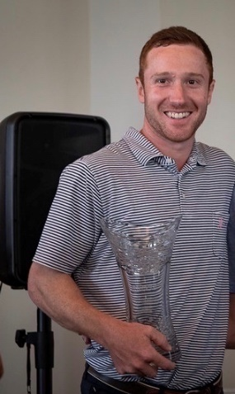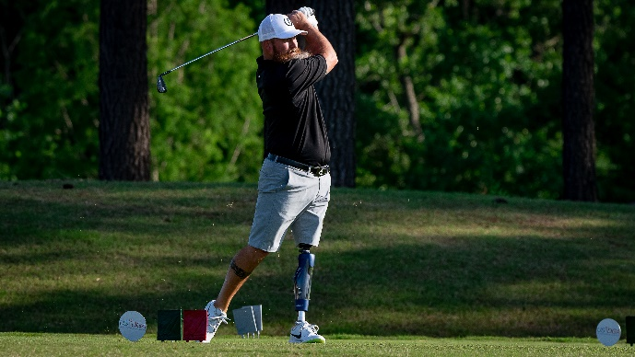

What others are saying

The 2019 Open was an overwhelming success for the entire Richmond Region. It was exciting to see so many community partners support the efforts of Jason and his Team at the USDGA to bring the Nation top adaptive golfers to Independence Golf Club. We highly encourage other destinations from around the country to consider partnering with the USDGA to bring a tournament to your area. We promise that your entire community- from the media to volunteers to businesses to golfers-will find value in supporting one of the most exciting events to visit the Richmond Region in Many years
-J.C. Poma, Sports Development Manager at Richmond Region Tourism

“Working together with Jason and helping him bring his dream to fruition and brought over 70 golfers from around the world with different disabilities together on one course. The community support he was able to garner far surpasses a lot of people’s expectations and I know he will be able to carry this success into future tournaments.”
Danish Saadat, Sports Services Manager @Richmond Region Tourism
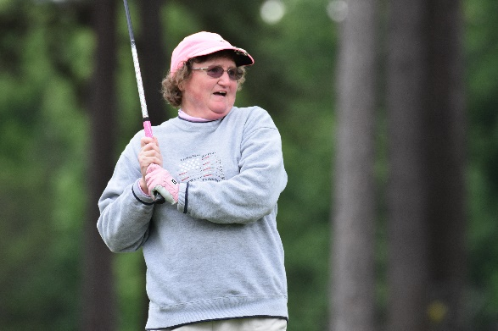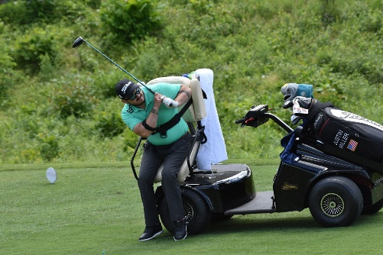

Dates
May 2022 and May 2023 ( Last of April, May is a Priority )

Event Fee and other Support
$5000 host fee annually: any combination of other cash/VIK (budget relieving)
Commitment to solicit other local sponsors to the tune of $20,000 annually is crucial for success
Expenses paid site visit for Founder to review course and amenities
Support of Player Opening Ceremony on night before event

Bid Deadline
The Announcement will be during the 2021 Open in May
Participants
60-100 Golfers +1 support/caddie
Length of Event:
4 days
Competition 3 competition days (54 holes) with 1 and 10 tee start plus Practice Rounds
Tear Down Post event
Please note that many players will come to your destination early to play the course; Please provide discounted green fees to practice rounds
Course/Venue Requirements:
The Americans with Disabilities Act, which went into effect January 26, 1992, requires that public establishments offer equal access and services to people who are physically and mentally disabled. The facility must agree that it will be in compliance with all applicable city, state or federal regulations concerning access and seating for people with disabilities.
Championship (Famous) Caliber Course with discounted Green Fees. The course should be in the top tier in your area. (City Courses will not be an option) For Golfers with disabilities, the course should be relatively flat or gently rolling hills.
Bunkers are to be made for accessible carts to drive into and out freely. Greens should be where accessible carts can drive on them. Roughly 10 players with accessible carts will be afforded this option
60 or more Golf Carts will be needed for golfers and volunteers.

Space for Opening, Closing Ceremony, Medical evaluation
Space for players meals after each competition rounds (include in price)
Host Hotel should be close to the course
International Airport should be close

LOC Responsibilities
Provide Director of Golf
On- Site Rules Director (State Association
Scoring Director

Sponsorship and in-kind item solicitation
Water/Gatorade
Volunteer meals
Players meals
On course signage
Coordinated Discount green fees

Volunteer recruitment and volunteer coordination (60 to 100 Volunteers a day)
1 Scoring volunteer per group
2 spotters on holes
Caddies to help some players
Other volunteers where needed

Solicit a headquarter hotel
Hotel Promotion
Exclusive right as Tournament Host Hotel
Host Facility information will be promoted in email, website and facebook that will be seen by more than 3000 people
Tournament Information will include features and amenities of the hotel to promote attendance

RFP Considerations
3 upfront complimentary 5 night rooms for usdga staff (Neg)
Low Rates for Players and Guests is a must
Free Breakfast for all guest if serve
$10 rebate per room per night book, Paid to the USDGA
Complimentary laundry for USDGA Staff, Up to 5
Complimentary high speed internet for USDGA Staff, Up to 5
1 per 25 room nights ( may be use by anyone giving permission before the tournament starts and shortly after)
Welcoming and Sponsor signs place on property

RFP Requirements
Room Block setup for individual reservation
No cancellation or attrition clauses
Cutoff date no earlier than 2 weeks prior to the start of the room block and allowance for USDGA Participants to receive group rates if still available

Coordinate Opening and awards ceremony
Coordinate Ceremonial First Tee shot
Local Officials
Sponsor Recognition
Media interviews
National Anthem
Entertainment
Sound System on 1 and 10th tee for player intro

Marketing, public relation and social media support
Special event Logo
Interview Coordination

Due Date, Venue and Site Inspection should be done before May 2021. Official announcement to the players will be during the 2021 US Disabled Open.

FMI Please contact Jason Faircloth at 910 214 5983 or email at jason@usdga.net

